**A Novel Approach to develop Energy Prediction Model for Large Industries using Artificial Intelligence**

**A Minor Project Synopsis Submitted to**



**Rajiv Gandhi Proudyogiki Vishwavidhyalaya, Bhopal**

**Towards Partial Fulfillment for the Award of**

**Bachelor of Technology**

**(Computer Science and Engineering)**

**Submitted By:**

**Kshitij Kotasthane (0827CS181105)**

**Medha Kasture (0827CS181116)**

**Manas Satpute (0827CS181111)**

**CS2 III YEAR**

**Supervised By: Guided by:**

**Mr. Rahul Patel Dr. Santosh Varshney**

**Ms. Nisha Rathi**

**Mr. Rahul Moriwal**



**Department of Computer Science and Engineering**

**Acropolis Institute of Technology and Research, Indore**

**July - Dec 2019**

**TABLE OF CONTENTS**

| **S. NO.** | **TOPIC** | **PAGE NO.** | **REMARK** |
| --- | --- | --- | --- |
| 1. | TITLE | 1 |  |
| 2. | INTRODUCTION | 1 |  |
|  | 2.1 PROJECT BENEFITS | 1 |  |
|  | 2.2 PROJECT SCOPE | 1 |  |
| 3. | PROBLEM STATEMENT | 1-2 |  |
| 4. | OBJECTIVES | 2 |  |
| 5. | INTENDED USER | 2 |  |
|  |  |  |  |
|  |  |  |  |
| 6 | LIMITATIONS |  |  |
| 7. | PROPOSED SYSTEM | 3 |  |
|  | 7.1 SYSTEM FEATURES | 3 |  |
|  | 7.2 PROCESS FLOW | 3 |  |
|  | 7.3 HARDWARE REQUIREMENTS | 3-4 |  |
|  | 7.4 SOFTWARE REQUIREMENTS | 4 |  |
| 8. | EXPECTED OUTCOMES | 4 |  |
| 9. | CONCLUSION | 4 |  |
|  | 9.1 LIMITATIONS | 4 |  |
|  | 9.2 FUTURE ENHANCEMENTS | 4 |  |
| 10. | REFERENCES | 5 |  |

**SYNOPSIS**

1. **TITLE**

Solar Power Forecasting using Machine Learning Techniques.

1. **INTRODUCTION**

The global shift towards renewable energy sources (RES) has driven the development of photovoltaic (PV) panels. The cost of producing electricity from PV panels have dropped significantly, while simultaneously increasing the conversion efficiency. More specifically, the levelized cost of largescale PV panels has decreased by 73% in the last decade. The decreased cost and increased efficiency have made PV panels a great competitive alternative as a RES in many countries.

It is likely, as more countries decide to invest more and more in RES, that the use of solar PV panels will continue decide to increase. This will increase the need for suitable means for forecasting solar PV energy output. While the demand for accurate and efficient forecast of PV panel is evident, the solution is far from trivial. There are many complications that the current research within the field is handling. One evident nuisance is the inherited variation of weather, which makes accurate weather forecasting challenging.

Parallel to the increased demand of PV power forecasting solutions, the means for forecasting with the help of machine learning(ML) techniques have in recent years gained in popularity to traditional time series predictive models. Although ML techniques are now new, the improved computation capacity and higher availability of quality data have made the techniques useful for forecasting. This poses for an interesting area of research when forecasting the solar power output.

* 1. **PROJECT BENEFITS**

1. Predict the amount of power generated.
2. Can be used by Solar Plants.
3. Reduces the manual efforts in energy prediction.

**2.2 PROJECT SCOPE**

The scopes of this project are:

* An important tool for Solar Energy Plants.
* Can be used by either producer or seller.

1. **PROBLEM STATEMENT**

The increased competitiveness of solar PV panels as a renewable energy source has increased the number of PV panel installation in recent years. In the meantime, higher availability of data and computation power have enable machine learning algorithms to perform improved production. However, since PV panel energy output depend on the weather condition such as cloud cover and solar irradiance, the energy output of PV panel is unstable.

To understand and manage the output variability is of interest for several factors in the energy market. In the short term (0-5 hrs), a transmission system operator is interested in the energy output from PV panel to find the adequate balance for the whole grid, since over and under producing electricity often results in penalty fees. On other side of the spectrum, electricity traders are interested in long time horizons, ordinarily, day ahead forecast since most electricity is traded on the day ahead market. Consequently, the profitability of these operations relies on the ability to forecast the fluctuating solar PV panel output accurately.

**4. OBJECTIVES**

1. To forecast Solar power for days.
2. To help maintain the PV panels more efficiently.
3. Save the time, money and effort.

**5. INTENDED USER**

The intended users are the operational solar power plant owners.

**6 LIMITATIONS**

Some limitations of the existing system are:

1. Requires proper dataset of energy generation every 15 min along with the temperature and the weather.
2. Skilled Engineers are required to handle the application.

**7 TECHNOLOGICAL REQUIREMENT**

1. Data analysis techniques and machine learning algorithms along with proper Python background to achieve maximum accurate result.
2. A platform for high performance computing, to run and test machine learning models.

For eg., Google Colab.

1. Appropriate medium to represent data interpretation and analysis to highlight differences between expected and achieved results.

**8 UML DIAGRAMS**

**8.1 USE CASE DIAGRAM**

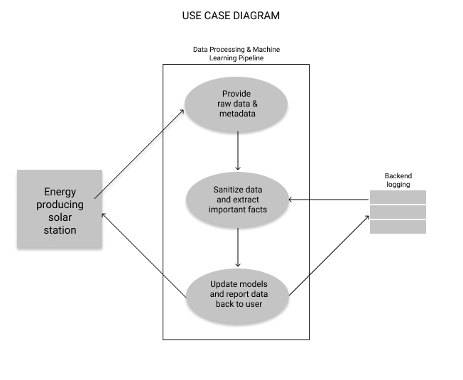

**8.2 ACTIVITY DIAGRAM**

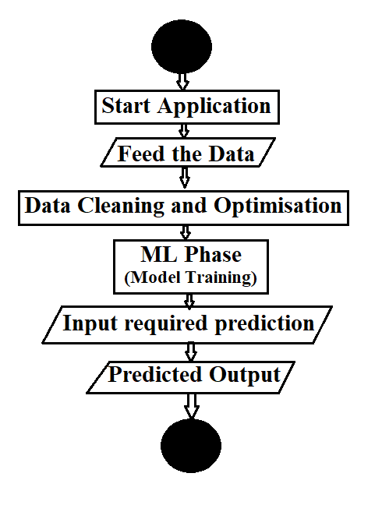

**8.3 DATA FLOW DIAGRAM**

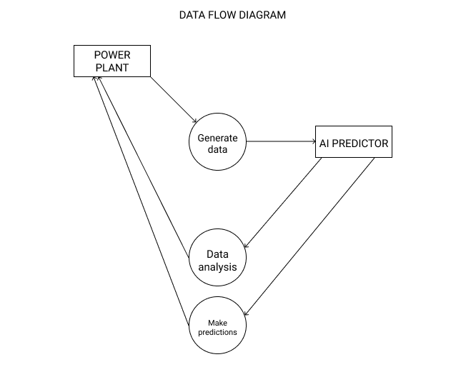

**8.4 CLASS DIAGRAM**

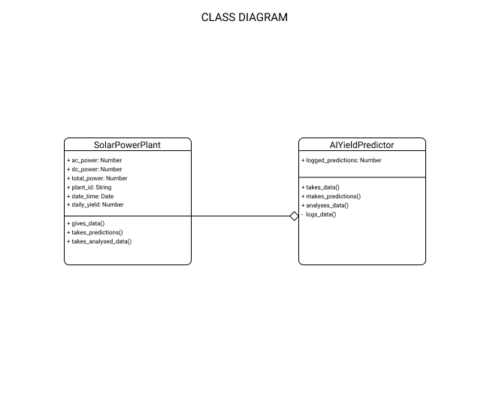

**8.5 ER DIAGRAM**

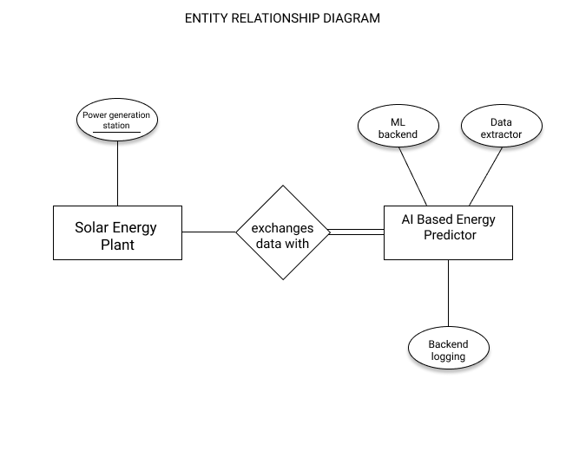

**9 KEY PERSONNEL AND THEIR EXPERTISE**

| **Particulars** | **Name and Designation** | **Expertise** |
| --- | --- | --- |
| ***Client and/or Sponsor*** | ***-*** |  |
| ***Team Lead*** | ***Kshitij Kotasthane*** | ***_*** |
| ***Team members***  ***With their roles*** | ***Kshitij Kotasthane*** | ***Building and fine tuning models*** |
| ***Manas Satpute*** | ***Data collection and cleaning*** |
| ***Medha Kasture*** | ***Loss estimation and data analysis*** |
| ***Guides names*** | ***Guide*** | ***Dr. SAntosh Varshney*** |
|  |  |
|  |  |

**10 PROPOSED TIMETABLE**

|  | **Description of Work** | **Expected no. of weeks to complete the phase** |
| --- | --- | --- |
| **Phase One** | **Energy consumption analysis of ML model** | **3** |
| **Phase Two** | **Analysis of algorithm behavior** | **3** |
| **Phase Three** | **Improving programming** | **5** |

**11 CONCLUSION**

This is to conclude that the project that we undertook was worked upon with a sincere effort. Most of the requirements have been fulfilled up to the mark and the requirements which have been remaining, can be completed with a short extension.This project would definitely satisfy all the requirements of the college and would be beneficial for the students and the college staff.

**12 FUTURE ENHANCEMENTS**

Can be implemented for other energy sources like wind, fuel, etc.

**13 REFERENCES**

1. IRENA. Renewable power generation costs in 2017. Technical report, International

Renewable Energy Agency, Abu Dhabi, January 2018.

1. Jose R. Andrade and Ricardo J. Bessa. Improving renewable energy forecasting

with a grid of numerical weather predictions. IEEE Transactions on Sustainable

Energy, 8(4):1571–1580, October 2017.

1. Rich H. Inman, Hugo T.C. Pedro, and Carlos F.M. Coimbra. Solar forecasting

methods for renewable energy integration. Progress in Energy and Combustion

Science, 39(6):535 – 576, 2013.

1. J. Antonanzas, N. Osorio, R. Escobar, R. Urraca, F.J. Martinez-de Pison, and

F. Antonanzas-Torres. Review of photovoltaic power forecasting. Solar Energy,

136:78–111, October 2016.

Signature of the Candidate Signature of the Guide Signature of the Supervisor